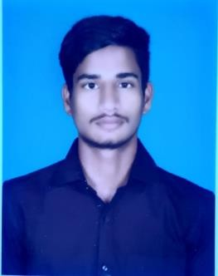GANESH.K

MICROBIOLOGIST

# ABOUT ME

Date of birth - 20.03.2001 Age - 22

Gender - Male Birth place - Thanjavur **CONTACT**

118,korrikulam new Pudhupattinam, Thanjavur-613006 9894524569

[kganesh2032001@gmail.com](mailto:kganesh2032001@gmail.com)

# SKILLS

**TECHNICAL SKILLS:**

* MS OFFICE

# PERSONAL SKILLS:

* Leadership
* Time Management
* Work Ethics

# EXPERTISE

* Microbiology
* Industrial Microbiology
* Food Microbiology
* Medical Microbiology

# CAREER OBJECTIVE

Seeking a position to utilize my knowledge, skills and abilities in the industry that offers competitive environment, a true profession to put in the acquired knowledge and gain exposure to upcoming technologies while being resourceful, innovative and flexible.

# ACADAMIC BACKGROUND

**2019-2022 -** B.Sc. Microbiology With DMLT SASTRA deemed to be University, Thanjavur .

**2022-2024-** M.Sc.microbiology

Bharath institute of higher education and research,Chennai.

# CERTIFICATION

* Completion of Career edge Knockdown the lock down at TCS ion.
* Employment Communication- a lab-based Course.
* Developing Soft Skills and Personality.
* Worked as a trainee at Vinodhagan Memorial Hospital (P) Ltd., Thanjavur.
* Worked as a trainee at Thanjavur District Co Operative Milk Producers Union Ltd (Aavin).
* Participate and presented a poster entitled as alternative medicine to combact infectious disease in the national conference on statergy in the control of infectious disease
* Participate in national conference on hazardous food chemicals on human health.
* Worked as trainee in pharma products (P) Ltd., Thanjavur.

# DECLARATION:

I hereby declare that the above furnished information is true to the best of my knowledge and I bear the responsibility for the correctness of the above mentioned particulars.

PLACE : DATE :